**Software Requirements Specification**

**Project Topic : Library Management System**

1. **Introduction (Client acceptance)**

This is a online library management system(eLibSys), where the librarian, members and guests can operate with. The librarian can do the book management. Members can avail library facilities, do payment etc. Guests can register an become members of the library.

* 1. **Purpose**

The main purpose of eLibSys is to make the operations of a library. More flexible and user friendly. Since this is a web Application, running on 24X7, the members can query or reserve for a book e at any time, even outside library working period.

* 1. **Intended Audience**

The main system user roles are as follows:-

* Application admin
* Librarian
* Member
* Guest (General Public)
  1. **Intended Use**

The system is developed for automating the library activities with user interactions. The system allows to register, login, and perform the user role activities.

* 1. **Scope**

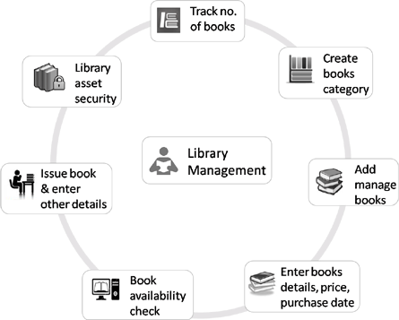

* 1. **Definitions and Acronyms**

**Definitions:-**

1. **Member** stands for a registered user of the system. The person need to register with the system, providing the required data and paid the fee, according to the membership
2. **Guest(General public)** is any person, browsing the application

**Acronyms:-**

1. **eLibSys** – Electronic Library System
2. **Overall Description (Client acceptance + Development team)**

This is a online library management system(eLibSys), where the librarian, members and guests can operate with. The librarian can do the book management. Members can avail library facilities, do payment etc. Guests can register an become members of the library.

* 1. **User Needs**

1. A library web application with a site, accessible to general public also
2. The library activities will be possible only for registered users of the system
3. A member can query, take, reserve, or return a library book
4. The librarian has to manage the library books data as well as issue, and take return of the book from a member.
5. Librarian can apply the rules for fine calculation, time to time.
   1. **Assumptions and Dependencies (Design/Development team)**
6. To use the library activities, a user should be registered first.
7. Different types of memberships are available with the library, which are been maintained by the librarian. The fee for each type are also different.

**3. System Features and Requirements**

**3.1 Functional Requirements**

The complete functional modules of the application includes the following:-

1. User Registration
2. User login
3. Browse for books
4. Manage the books
5. Perform library activities
6. Change password
7. User management
8. Fee/fine sub-system
9. Withdraw membership
10. Logout

**Functional requirements in detail**

* + 1. **User Registration**

1. For the **user** registration, the librarian has to add different types of memberships and the respective fee details. Data are as follows:-
2. MemType
3. Description
4. Fee
5. In this functionality, any general public user can register himself/herself to the system. The data required to identify the members are as follows:-
6. UserID
7. Name
8. Address
9. Password
10. Contact number
11. membershipType
12. email

There is constraint on the memberID, which can not be duplicated. This should be Unique for every member.

After submitting the registration form, based on the membership type, the fee is calculated and displayed to the user. He need to pay the amount to the library.

Once the payment is done by the user, **librarian** has to update the payment status of the person. Thereafter, the member can perform any library related activities.

When a member has been registered, the status of that member will be kept as TRUE by default.

* + 1. User login

There are major User roles for the system. They are Application admin, Librarian and member. The System users has to login to perform the system activities.

The users need to provide UserId and Password to login. The data is validated with the database and if validated successfully, the status of the user is checked to be TRUE. If found true, the User session will start and the user gets the Home page for the user role.

1. **Librarian**

Home page of Librarian provide options to perform the following activities:-

* 1. Member management
     1. Edit the status of a member
  2. Book management
     1. Add new books to library
     2. Edit an existing book
     3. Remove a book from library (status to false)
  3. Library activities
     1. Issue a book to a member
     2. Return the book
        1. Fine applied, if applicable
     3. Manage the fee
     4. Manage membership types
     5. Manage fine and due period

1. Member
2. Application Admin
   * 1. Browse for books
     2. Manage the books
     3. Perform library activities
     4. Change password

This facility allows the users to change their current password. In order to do this, they need to provide the current password and the new password.

When the values are submitted, system has to check if the old password of the user is valid or not. If valid, the new password will be updated in the database for the user. If the old password is not matching, a proper error message has to be displayed to the user.

* + 1. User management
    2. Fee/fine sub-system
    3. Withdraw membership
    4. Logout

**3.2 External Interface Requirements**

**3.3 System Features**

**3.4 Nonfunctional Requirements**